**GNUVARIO-E**

**QUECTEL L86-M33**

L86 GNSS Protocol Specification:

****************************************************************************************************************

**Structure of MTK NMEA Packet**

$PMTKXXX,Y,Y,Y,Y*CHECKSUM<CR><LF>

with XXX packet type from 000 to 999

Y,Y,Y Data fields, delimited by comma.

Exemple:

$PMTK301,2*2E<CR><LF>

301 is packet type,

2 is data field

2E checksum.

<CR><LF> carriage return, line feed

To calculate checksum : copy sentence between $ and * and past on ASCII Input calculator:

<https://www.scadacore.com/tools/programming-calculators/online-checksum-calculator/>

****************************************************************************************************************

Useful function for the GNUVario

****************************************************************************************************************

DGPS :

Enable DGPS

$PMTK301,2*2E<CR><LF>

Deseable DGPS

$PMTK301,0*2C<CR><LF>

DGPS is for us SBAS : <https://www.gsa.europa.eu/european-gnss/what-gnss/what-sbas>

****************************************************************************************************************

Satellite elevation mask : <https://itstillworks.com/definition-j-s-jamming-gps-12212859.html>

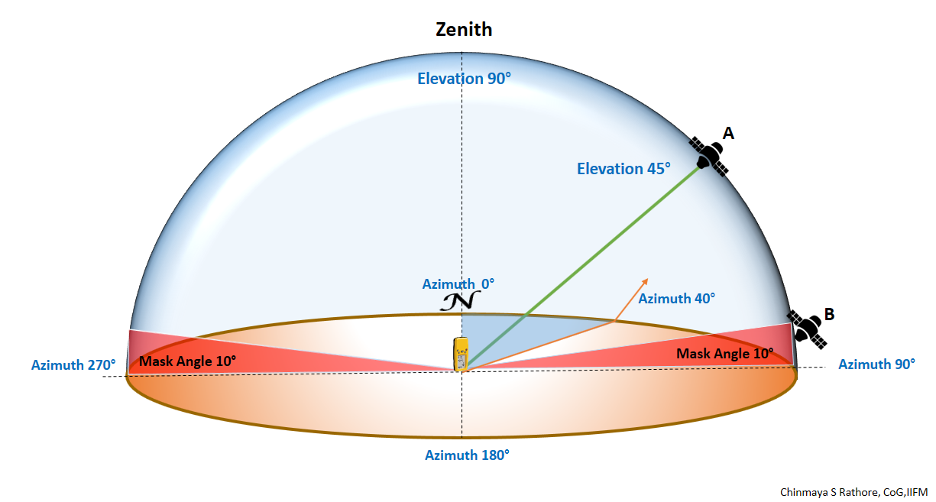

$PMTK311,15*19<CR><LF> --->15°

$PMTK311,10*1C<CR><LF> --->10°

$PMTK311,5*28<CR><LF> --->5°

The satellite elevation mask is recommended to be set not more than 10 degrees. As with the increase of satellite elevation mask, the number of satellites involved in positioning will decrease.

****************************************************************************************************************

NEAMA sentence output frenquencies : 19 datafields.

0: GLL interval - Geographic position, latitude and longitude

1: RMC interval - Recommended minimum specific GNSS sentence

2: VTG interval - Course over ground and ground speed

3: GGA interval - GPS fix data

4: GSA interval - GNSS DOPS and active satellites

5: GSV interval - GNSS satellites in view

6: GRS interval - GNSS range residuals

7: GST interval - GNSS pseudorange error statistics

8 to 16 reserved, always 0

17: ZDA interval – Time and date

18 MCHN PMTKCHN interval – GNSS channel status ?

For sentences: 0,1,2,3,4,5:

$PMTK314,1,1,1,1,1,1,0,0,0,0,0,0,0,0,0,0,0,0*34<CR><LF>

GNUVario-E read only GNRMC and GPGGA

$PMTK314,0,1,0,1,0,0,0,0,0,0,0,0,0,0,0,0,0,0*34<CR><LF>

***************************************************************************************************************

Choose satellite system :

$PMTK353,1,0,0,0,0*2A<CR><LF> -------------->GPS

$PMTK353,1,1,0,0,0*2B<CR><LF> -------------->GPS+GLONASS

$PMTK353,1,1,1,0,0*2A<CR><LF> -------------->GPS+GLONASS+GALILEO

$PMTK353,1,1,1,1,0*2B<CR><LF> -------------->GPS+GLONASS+GALILEO-FULL ?

$PMTK353,1,0,1,0,0*2B<CR><LF> -------------->GPS+GALILEO

$PMTK353,1,0,1,1,0*2A<CR><LF> -------------->GPS+GALILEO-FULL

$PMTK353,0,0,1,1,0*2B<CR><LF> -------------->GALILEO-FULL

********************************************************************************************************************************************************************************************************************************

**NMEAOutput description**

$GPGGA Time, position, and fix related data of the receiver.

$GPGLL Position, time and fix status.

$GPGSA Used to represent the ID’s of satellites which are used for position fix.

$GPGSV Satellite information about elevation, azimuth and CNR

$GPRMC Time, date, position, course and speed data.

$GPVTG Course and speed relative to the ground.

$GPZDA UTC, day, month and year and time zone.

**GNUVARIO-E :**

[**http://navspark.mybigcommerce.com/content/NMEA_Format_v0.1.pdf**](http://navspark.mybigcommerce.com/content/NMEA_Format_v0.1.pdf)

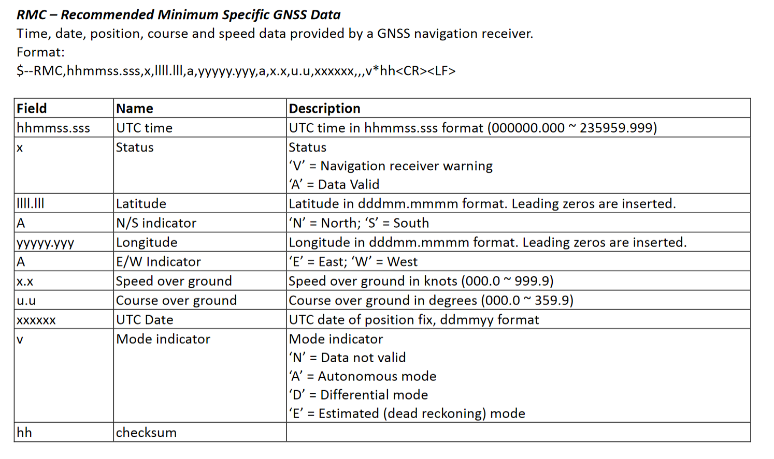

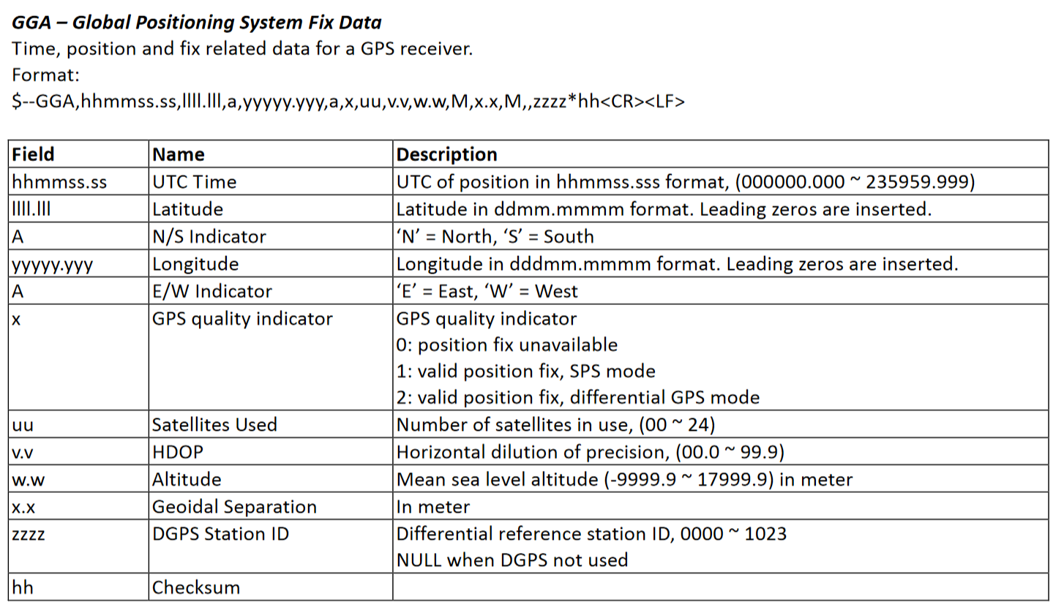

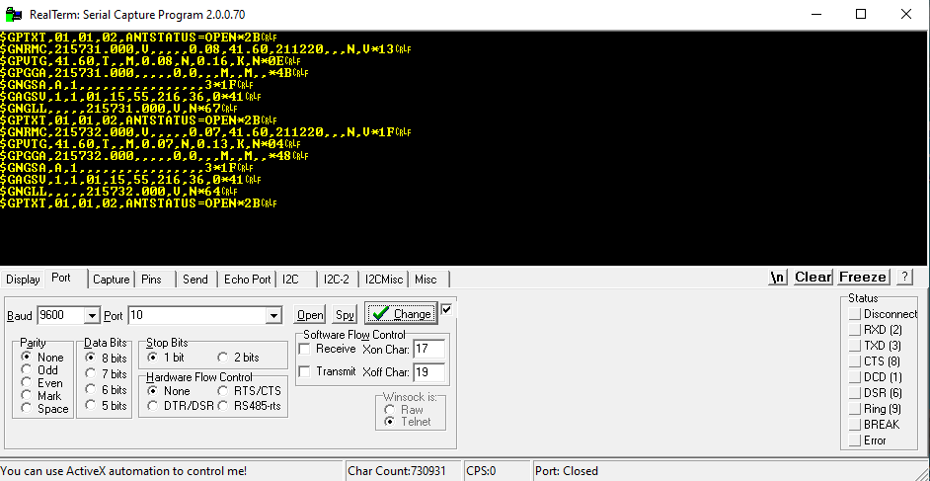

**Send NMEA packet to GPS via FDTI USB**

